Dear Parent / Teacher,

Your child / students will be participating in the Dunk the Funk program presented by McMillen Health on .

According to the Centers for Disease Control, nearly 22 million school days are missed each year due to the common cold. Addressing proper hygiene practices - including effective hand-washing - is essential to the health of students and school personnel. Using practical tips, humor and videos, this age-appropriate program covers many hygiene related topics including handwashing, showering, dental hygiene, skin care, clothing care, nail care, and menstrual hygiene practices. Participation in this program prepares students for the transition into adolescence and explains how self-care and success relate. This program is appropriate for both males and females. A brief introduction to the anatomy and physiology of the menstrual cycle is included.

Our goal is to provide a learning experience that is both fun and informative. Please email me at sgleason@mcmillenhealth.org or call me at 260-456-4511 or toll free at 1-888-240-7268 should you have any questions concerning this program. If I am not available, another Health Educator will be happy to assist you!

Thank you for scheduling this program with McMillen Health!

Sincerely

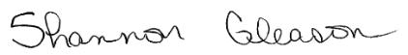
Shannon Gleason
Director of Educational Services

