Dear Parent / Teacher,

Your child / students will be participating in the Cloud of Concern 3.0 program presented by McMillen Health on .

It’s just harmless water vapor, right? Join us as we correct this common misconception about vaping by using feathers to demonstrate the difference between water vapor and aerosol. Hear the Chemical Crew’s concerns about being misused in vaping devices. Students learn how vaping negatively impacts the major organs of the body with the help of Carpet Kid. Students finish by practicing refusal skills to thwart potential peer pressure to vape.

Our goal is to provide a learning experience that is both fun and informative. Please email me at sgleason@mcmillenhealth.org or call me at 260-456-4511 or toll free at 1-888-240-7268 should you have any questions concerning this program. If I am not available, another Health Educator will be happy to assist you!

Thank you for scheduling this program with McMillen Health!

Sincerely,

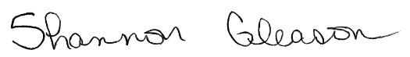

Shannon Gleason
Director of Educational Services

